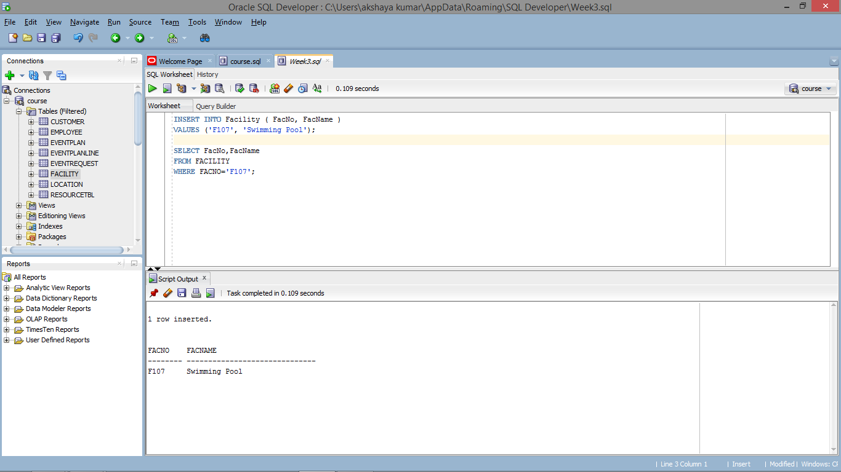

INSERT INTO Facility ( FacNo, FacName )

VALUES ('F107', 'Swimming Pool');

SELECT FacNo,FacName

FROM FACILITY

WHERE FACNO='F107';